**Day 6**

1. Categorize products by stock status

(Display product_name, a new column stock_status whose values are based on below condition

units_in_stock = 0 is 'Out of Stock'

units_in_stock < 20 is 'Low Stock')

**Query:**

SELECT

product_name,

CASE

WHEN units_in_stock = 0 THEN 'Out of Stock'

WHEN units_in_stock < 20 THEN 'Low Stock'

ELSE 'In Stock'

END AS stock_status

FROM

Products;

**Output:**

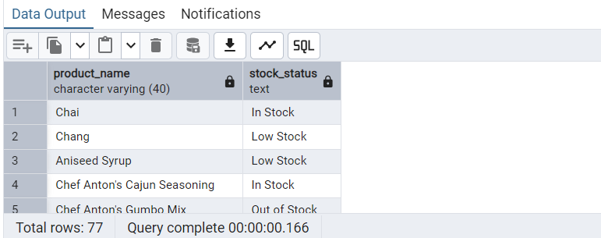

2. Find All Products in Beverages Category

(Subquery, Display product_name,unitprice)

**Query:**

SELECT product_name, unit_price

FROM products

WHERE category_id = (

SELECT category_id

FROM categories

WHERE category_name = 'Beverages'

);

**Output:**

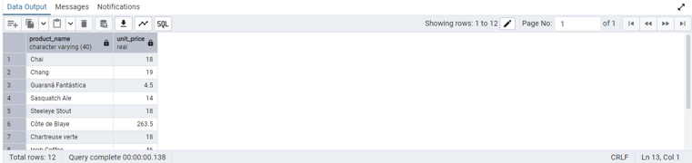

3. Find Orders by Employee with Most Sales

(Display order_id, order_date, freight, employee_id.

Employee with Most Sales=Get the total no.of of orders for each employee then order by DESC and limit 1. Use Subquery)

**Query:**

SELECT order_id, order_date, freight, employee_id

FROM orders

WHERE employee_id = (

SELECT employee_id

FROM (

SELECT employee_id, COUNT(*) AS total_orders

FROM orders

GROUP BY employee_id

ORDER BY total_orders DESC

LIMIT 1

) AS top_employee

);

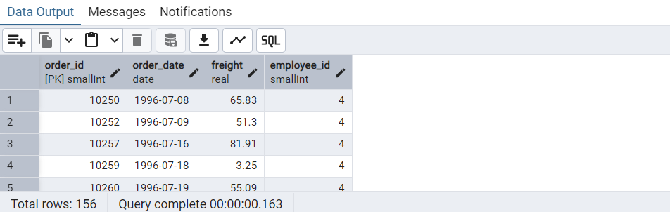

4. Find orders where for country!= ‘USA’ with freight costs higher than any order from USA. (Subquery, Try with ANY, ALL operators)

**Query:**

FROM orders

WHERE ship_country != 'USA'

AND freight > ANY (

SELECT freight

FROM orders

WHERE ship_country = 'USA'

);

**Output:**

